Exercise 1: Setting Up JUnit

Step 1:-

Created a new java project named SampleProject

Step 2:-

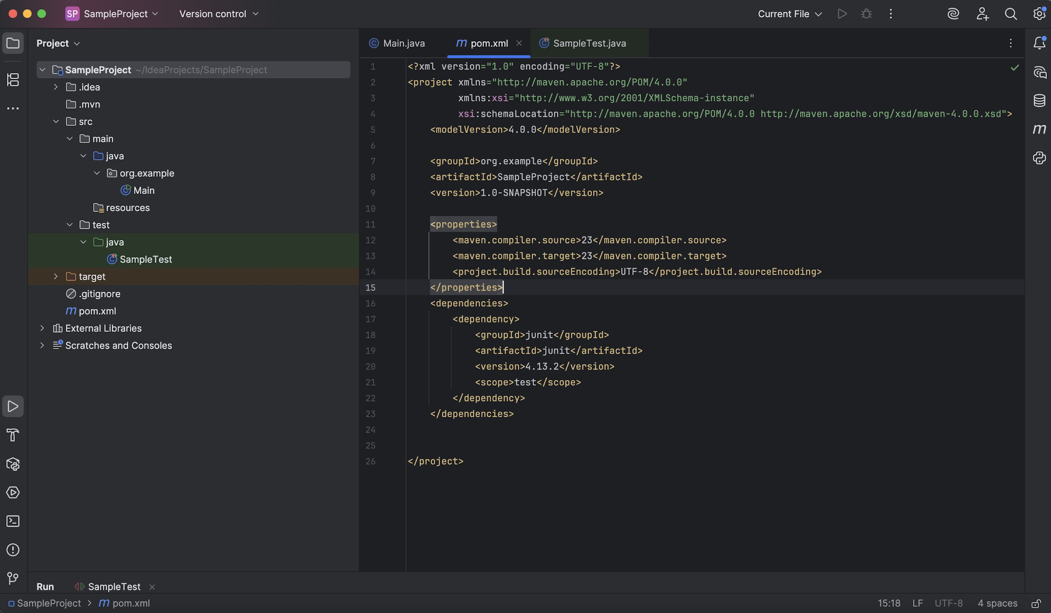Added JUnit dependency to the project

Step-3:-

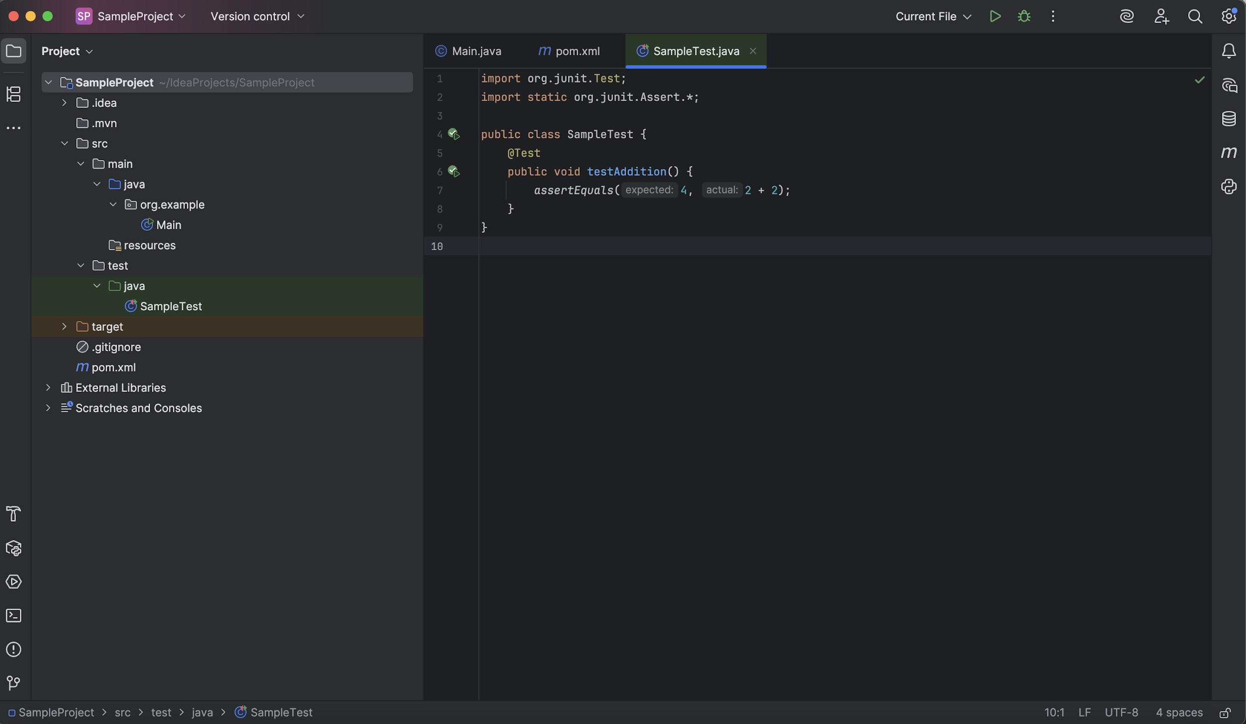Created a new test class for the project

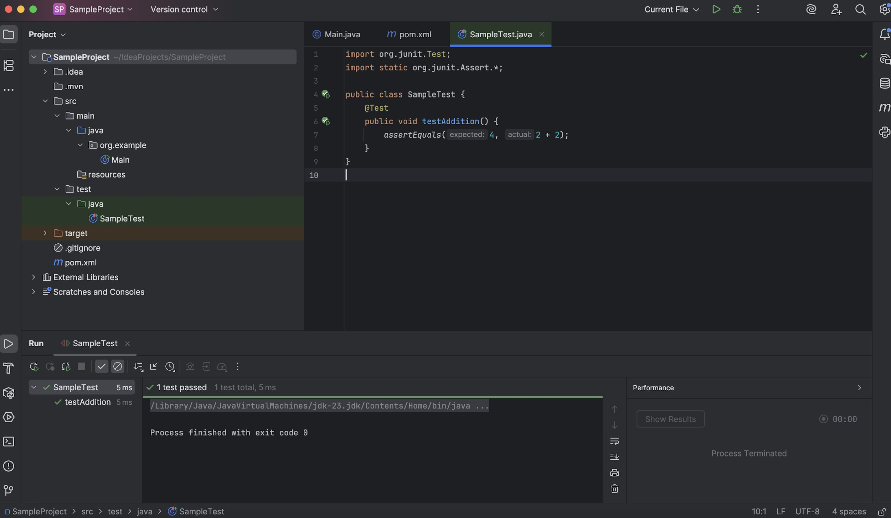Output: